Project Documentation

Our website is dedicated towards **interconnecting patients and doctors** in Liechtenstein in a **new innovative** way. With **advanced features** and **seamless integration**, we aim to improve patient care and enhance overall healthcare outcomes.

This vision statement of ours can be split of into several key word that and will be elaborated in more in more detail in the following paragraphs.

**Interconnecting Patients and Doctors**

The main aim of our website is to connect the citizens of Liechtenstein with doctors in times of sickness. A problem that is faced by many people is that they get ill and do not know which doctors are available and who could help them. They can only pinpoint a few symptoms and as a next step google these to get an idea of what type of illness they may have. Finally, they then search for a doctor who treats this illness based on the information they found out through previous Google searches. However, this is often very time-consuming, and often proves itself to be rather difficult.

**Problem Identification:**

Liechtenstein is a small country, and many will assume that finding the right doctor is a less challenging process than in other countries. However, despite the size of the country, it is a challenge for the patients to find the right medical assistance. This problem can manifest in many ways:

* Limited knowledge of the available doctors: often patients have insufficient information about the doctors, their specialties, and their availability. This may result in some sort of hesitation to seek medical treatment.
* Self-Diagnosis using the internet: commonly, when individuals experience symptoms of illness, the first step is to look up these symptoms online. While this can provide some insights, it often leads to misdiagnosis and further confusion about the right doctor the patient should consult.
* Lack of healthcare platforms: despite the small size of the country (as mentioned previously), there is no centralized system or platform that allows patients to input their symptoms and receive recommendations for suitable doctors.
* Healthcare cost: the cost of living in Liechtenstein is very high, in addition to all the reasons mentioned above, the patient may end up consulting multiple doctors before finding the right one. This will automatically lead to increased costs.

**Advanced Features**

This is where our LIE HEALTHCARE platform comes in as a *solution*!

The idea is to have the chatbot as the main feature of our website. The functionality behind this chatbot is that patients can enter our website and access the chatbot. The bot will then ask the patient for the symptoms they have. Depending on the symptoms they reply with, the chat will then redirect the patient to the page of doctors that can treat these accordingly.

**Seamless Integration**

A priority of ours is to make sure we stay in close contact with the users of our website. We aim to keep the information up to date and answer all questions anyone may have. Therefore, we added a contact page to our website. The users can get in touch with us through E-Mail or the phone and express any concerns or questions they may have. This way any doctors that are not listed on website can send us their details and ask to be added to our platform. We can be contacted every day a week and strive to reply within one or two workdays. Furthermore, a Q & A section can be found on our homepage. This segment is updated by our team at the end of each month with the most common questions asked. All in all, this allows us to strive for a seamless integration, of any new doctor’s information as well as answers to general questions, on our website.

**New Innovative**

What makes our solution so new and innovative? Liechtenstein has roughly 39’000 citizens which makes it a very small country. Yet, there is still no platform that offers the service that we do. When conducting research, we found platforms where patients can directly book appointments with doctors in Liechtenstein yet, they still must search for the doctors name a profession in advance.

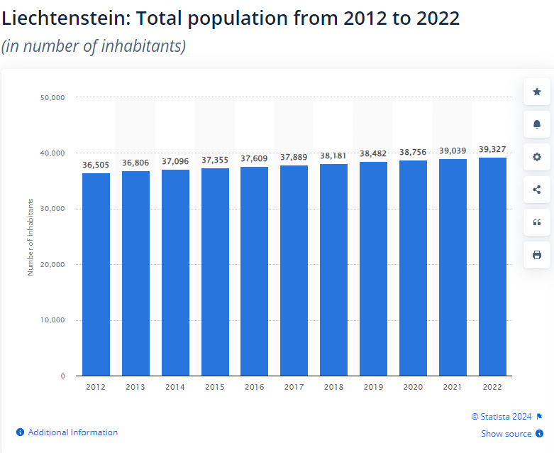

Source: https://www.statista.com/statistics/457653/total-population-of-liechtenstein/

Our platform allows patients to *save time* and *effort* that they need for this search process. Once the patient has entered their symptoms into the chatbot and has received a list of doctors that treat these symptoms, our platform redirects the patients to the homepage of the doctor where they can then book an appointment.

Future, steps of our platform could be to also integrate an appointment booking page on our website, which the patients are then redirected to, instead of the doctor’s homepage. This could then be used by them to directly book appointments. We are aware that this additional feature would make our platform even more convenient for the citizens of Liechtenstein, however, do to time issues we have not implemented this step yet.

**Our Aim**

Our platform is designed with the primary goal of increasing the standard of patient care in Liechtenstein and we aim to improve patient care and enhance overall healthcare outcomes.

Easy to use and Accessible platform: with a user-friendly interface, our website is accessible to all people who live in Liechtenstein (including foreign students), regardless of their age and their technological knowledge, our goal is to ensure that everyone can benefit from this improved healthcare service.

Minimize self-diagnosis errors: the platform will guide the patients toward the right and appropriate professional for their specific case. This will help drive away the users from unreliable online sources and minimize the risks of misdiagnosis and inappropriate treatments.

Accurate matching with doctors: our chatbot technology ensures that patients are matched with doctors who specialize in treating the specific symptoms mentioned by the patient. This will lead to better accurate and efficient care.

General healthcare platform: the platform provides information about many available doctors in the country. The users can input the symptoms they are feeling and get recommended to the appropriate doctors. This process will not take more than minutes and will save a lot of time and stress which often involved in finding medical care.

The platform results in:

* Efficient healthcare platform: connecting the patients to the right doctors will help reduce all the time and energy involved (from the medical care specialist and patients) in this process. The platform then will increase the focus on medical care rather than the bureaucracy of the process.
* Data-driven insights: the data collected through our platform can provide valuable insights into common health concerns and trends in Liechtenstein. This will enable us as a platform to better understand and respond to the user's needs.
* Improved healthcare resource allocation: the insights gained from the platform can help assist healthcare authorities in better resource allocation and planning.

**Known Issues**

* The code of the chat is very short and only covers a few questions and replies that could be entered by the user.
  + For it to work efficiently it should cover all possible cases, which may occur between the user and the chat.
    - Our suggestion for a future code would be to present the user with many combinations of possible symptoms that they may have: labeled a,b,c,d,.. Based on their reply, the bot will then redirect the user directly to the webpage naming doctors that are able to treat these symptoms.
* The chat is not integrated into our webpage due to us not having a chatbot interface.
  + We tried to program a chatbot from scratch. That do not work due to several reasons.
    - Our new suggestion to tackle this problem would be to take the whole concept described in the paragraph before and code this using python. The next step would then be to create a discord chat bot based on this python script and then finally use the bot API to integrate it into our website.

**Task Assignment**

Khalil Habiba – Creation of homepage, Programming chatbot

Siddiq Abubakar – Creation of Website except for homepage

Boudarat Sarah – Creation of excel sheet with doctors’ information, Documentation

Lynn Weisker – Creation of excel sheet with doctors’ information, Documentation